**Recommendations for Big Mountain Resort**

**Problem Identification**

Big Mountain Resort has recently installed an additional chair lift which has increased their operating costs by $1,540,000 this season. The business needs to select a better value for their ticket price to offset the additional operating cost. The costs have to be reduced without undermining the ticket price and increase the ticket price by providing commensurate value.

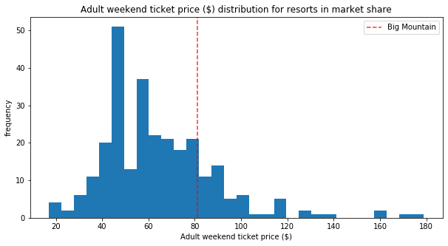

**Recommendations**

Big Mountain is currently charging $81 and the Big Mountain resort modelled price is $94.22 with an expected mean absolute error of $10.39, which suggests there is room for an increase in the ticket price. So, the ski resort is definitely undercharging when compared with other resorts throughout the US. If it adds another Run and increases the vertical drop by 150 feet and installs an additional chair lift then it further supports a price increase by $1.99 and total revenue increase by $3,474,638.

Big Mountain was already fairly high on some of the league charts of facilities offered, but it undervalued its facilities and that is the reason for the current low pricing. The current price can be safely increased and it will easily cover the additional operating cost of the lift and also generate more revenues for the business. The business can definitely use this model in the future in case any feature is added or removed and the price has to be adjusted accordingly.